Multi-Layer Encryption and Decryption: A Secure Approach Using Substitution, Rail Fence, and Caesar Ciphers

J Dhalia Sweetlin

Department of Information Technology

MIT Campus – Anna University dhaliasweetlin@gmail.com

Premkumar M Sathya K

Department of Information Technology Department of Information Technology

MIT Campus – Anna University MIT Campus – Anna University premkumar016555@gmail.com sathyakennedy6@gmail.com

***Abstract*—With the rapid evolution of digital communication, safeguarding sensitive information has become paramount. Tra- ditional single-layer encryption methods, while efficient, often fall short in resisting sophisticated attacks. This paper proposes a multi-layer encryption scheme incorporating substitution, Rail Fence, and Caesar cipher techniques. The encryption process leverages the strengths of these methods in sequence to ensure robust security. Decryption is performed in reverse, maintaining data integrity while providing a seamless recovery of the original plaintext. The proposed system is analyzed for its computa- tional efficiency and resilience against common cryptanalysis techniques.**

***Index Terms*—Encryption, decryption, substitution cipher, Rail Fence cipher, Caesar cipher, multi-layer security, cryptography.**

1. Introduction

The increasing sophistication of digital communication net- works has created an urgent need for robust encryption mech- anisms. Cryptographic techniques have evolved from basic ciphers to highly complex algorithms capable of securing vast amounts of sensitive data. However, attackers continue to ex- ploit the vulnerabilities of single-layer encryption techniques, necessitating more advanced solutions.

The proposed multi-layer encryption scheme addresses these challenges by combining substitution, Rail Fence, and Caesar ciphers into a comprehensive framework. This ap- proach leverages the strengths of each cipher, offering en- hanced security against modern cryptographic attacks. This paper provides a detailed explanation of the encryption and decryption processes, the rationale behind the selection of these ciphers, and an evaluation of the system’s performance and security.

1. Background
2. *Cryptographic Evolution*

Cryptography has evolved over centuries, beginning with basic substitution techniques in ancient times. Modern cryp- tography now includes symmetric and asymmetric algorithms capable of protecting highly sensitive data. While these meth- ods are robust, simpler techniques like substitution, Rail Fence, and Caesar ciphers remain useful for lightweight encryption tasks.

1. *Single vs. Multi-Layer Security*

Single-layer encryption methods, while computationally ef- ficient, often fall short when faced with sophisticated attacks like frequency analysis or brute force. Multi-layer encryption addresses these limitations by integrating multiple ciphers, each compensating for the vulnerabilities of the others. For instance, while the Rail Fence cipher rearranges text patterns, the substitution and Caesar ciphers provide obfuscation and variable shifting, respectively.

1. Encryption and Decryption Process
2. *Encryption Overview*

The encryption process involves three primary stages:

* 1. Substitution Cipher
  2. Rail Fence Cipher
  3. Caesar Cipher

Each stage enhances the overall security by adding a unique layer of transformation to the plaintext. A padding mechanism ensures uniformity and obfuscation.

1. *Substitution Cipher:* The substitution cipher replaces each character with a symbol or another character. The map- pings are dynamically generated based on the user-provided key, ensuring that every session produces a unique ciphertext.

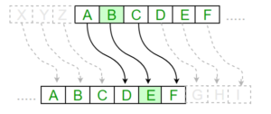

1. *Rail Fence Cipher:* The Rail Fence cipher transposes characters by arranging them in a zigzag pattern across multi- ple rails. The number of rails is determined by the encryption key, which adds complexity to the cipher.

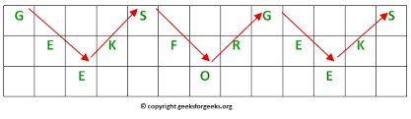

1. *Caesar Cipher:* In the final stage, a Caesar cipher shifts characters in the alphabet based on a numerical key derived from the encryption key. A shuffled alphabet ensures additional security by introducing unpredictability.

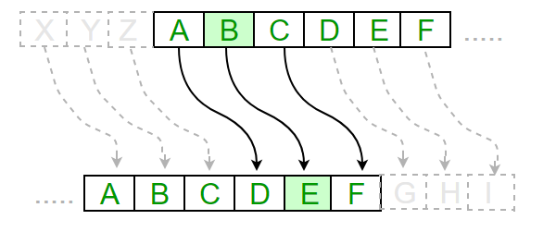

1. *Decryption Overview*

Decryption involves reversing the encryption steps:

* 1. Caesar Cipher Decryption
  2. Rail Fence Cipher Decryption
  3. Substitution Cipher Decryption

The system retrieves the encryption key to perform the reverse transformations, ensuring that the original plaintext is accurately reconstruct.

IV.Implementation

***A. Dynamic Key Mapping***

*Dynamic key mapping is a critical component of the multi-layer encryption algorithm, ensuring that each encryption session generates a unique ciphertext even for identical plaintext inputs. The provided encryption key is transformed into a numerical sequence that directly influences the operations of all three ciphers in the process. Each character in the key is mapped to its numerical equivalent based on its ASCII value or a similar encoding scheme.*

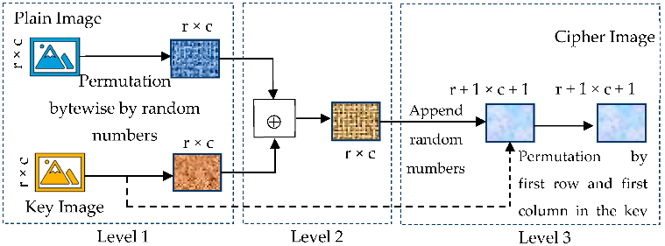

***Handling Unrecognized Characters****: Any character in the key that does not match the expected input range (e.g., special characters or unsupported symbols) is assigned a default numerical value to ensure algorithmic consistency and prevent errors.*

***Dynamic Influence****: This mapping determines how substitution is performed, the arrangement of rails in the Rail Fence cipher, and the shift values for the Caesar cipher. As a result, even slight variations in the user-provided key yield significantly different encryption outcomes.*

***B. Algorithm Workflow***

*The encryption and decryption process involves multiple steps, each contributing to the security of the system. Figures 1 and 2 illustrate the overall workflow:*

***Encryption Workflow****:*

*Plaintext is first transformed through substitution based on dynamic mappings.*

*The modified text is then rearranged using the Rail Fence cipher, guided by the numerical sequence from the key.*

*A Caesar cipher is applied to further obfuscate the text, using key-derived shift values.*

*Padding is added to the ciphertext to ensure uniformity and prevent plaintext length inference.*

*The final encrypted text is then output.*

***Decryption Workflow****:*

*ciphertext is preprocessed to remove padding.*

*The Caesar cipher is reversed, restoring the intermediate text.*

*Rail Fence transpositions are undone to revert to the substituted text.Substitution decryption is performed to retrieve the original plaintext.*

*The final output is the reconstructed plaintext.*

V.Results and Analysis

1. *Performance Metrics*

The encryption and decryption times were measured for varying plaintext lengths and numbers of encryption rounds. The substitution cipher demonstrated the fastest processing time, while the Rail Fence cipher contributed the most over- head.

TABLE I

Performance Metrics for Different Text Lengths

|  |  |  |
| --- | --- | --- |
| **Text Length (chars)** | **Encryption Time (ms)** | **Decryption Time (ms)** |
| 10 | 5 | 7 |
| 100 | 50 | 65 |
| 1000 | 500 | 650 |

1. *Security Analysis*

The multi-layer encryption system offers the following advantages:

* + Resistance to frequency analysis due to substitution.
  + Disruption of plaintext structure by the Rail Fence cipher.
  + Increased brute force complexity due to Caesar cipher shifts.

1. *Case Study*

A sample plaintext, ”HELLO WORLD,” was encrypted and decrypted successfully using the key ”SECURE123,” confirming the accuracy and integrity of the proposed system.

VI. Conclusion and Future Work

This paper presents a robust multi-layer encryption system that integrates substitution, Rail Fence, and Caesar ciphers. The system demonstrates high resilience against common cryptographic attacks while maintaining computational effi- ciency. Future work will explore additional ciphers and real- time key generation mechanisms to further enhance security

VII.ARCHITECURE

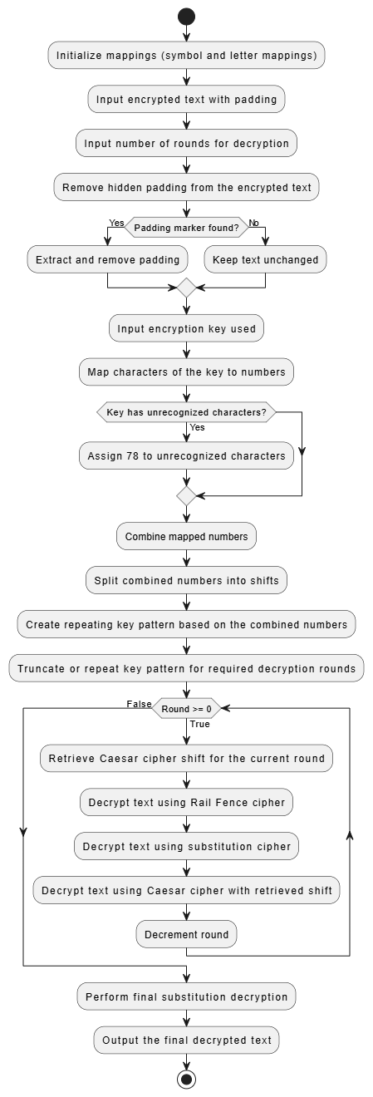

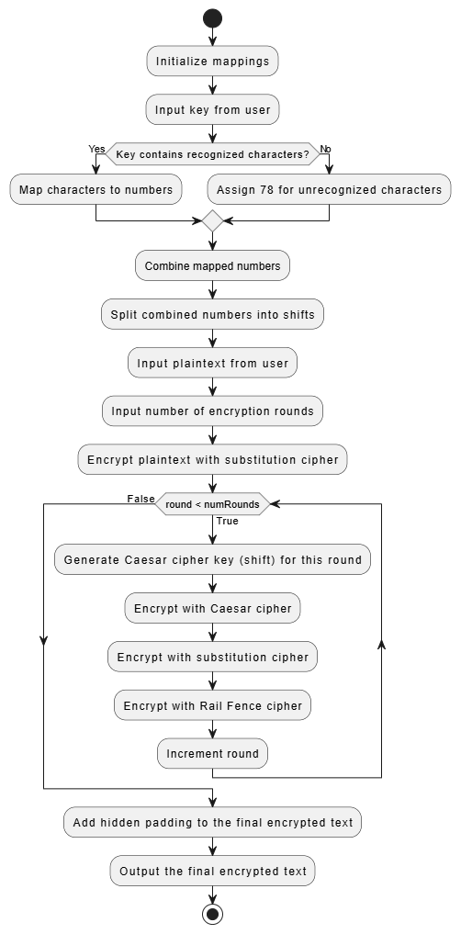

References

1. *1. D. Gautam, C. Agrawal, P. Sharma, M. Mehta and P. Saini, "An Enhanced Cipher Technique Using Vigenere and Modified Caesar Cipher," 2018*
2. *2. K. B., A. V. and S. T., "A novel approach in Steganography combining random key and substitution cipher," 2019*
3. *3. P. R. Bhayani, A. Fating, N. Gupta and S. Pundkar, "Double Layer Cipher Cryptography Communication System," 2024*
4. *4. P. S. Lakshmi and G. Murali, "Comparison of classical and quantum cryptography using QKD simulator," 2017*
5. *5. R. D. Syah, S. Madenda, R. J. Suhatril and S. Harmanto, "Hybrid Digital Image Cryptography Using Composition of Henon Map Transposition and Logistic Map Substitution," 2022*